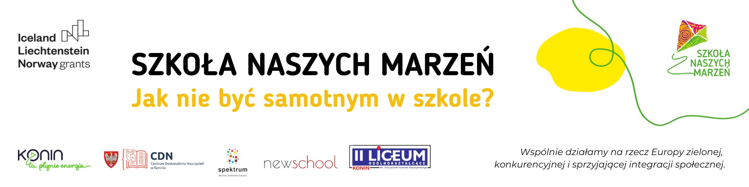

**PEDAGOGICAL INNOVATION**

**organizational and methodological**

**"Long-term investment"**

**developed for implementation under the grant**

**School of Our Dreams.**

**How not to be lonely at school?**

**Name of the school:** Secondary School No. 2. Krzysztof Kamil Baczyński in Konin

**Authors:** Aneta Bylewska – Kurek, Bartosz Michalak, Małgorzata Koziarska – Sip, Barbara Jaworowicz, Aldona Olesiak

**Topic:** Long-term investment

**Subject:** history

**Type of innovation:** organizational and methodological

**Date of introduction: 04/09/2023**

**End date: 19/01/2023**

**Scope of innovation:**

The recipients of the innovation are students of class III f. The implementation time of the innovation covers the first half of the school year 2023/2024 with the possibility of continuing it. Innovative classes will take place as part of history lessons. This innovation aims to spread the ideaof ​​self-development and self-esteem using the Journal of Science application.

**Motivation for introducing innovation:**

The "Long-term investment" innovation is a response to the diagnosis as part of the "How not to be lonely at school?" project, which indicates the needs of students in the learning process. Students commented: "Students do not know the assessment criteria for a given part of the material. They are not sure what they need to learn to be successful. They do not know what is important in a given topic, they do not know the assessment criteria for a given grade. Teachers often require content that they have not included in their assessment policies at all. This reduces motivation, discouragement and enormous stress related to tests, quizzes or any forms of knowledge testing, and may additionally lead to avoiding classes. It is difficult to assess one's own learning outcomes and remain calm if the student is not familiar with clear and transparent assessment rules and knowledge requirements. It is difficult to manage your own learning and decision-making process.” The inspiration to introduce the innovation was the positive experience of the teacher and students during the pilot work with the application in May 2023. The added value of the introduced innovation will be the strengthening of positive relationships between the teacher and students, which are the basis for effective learning.

**Description of the innovation:**

**I. Introduction**

Secondary School No. 2 in Konin is a school achieving high teaching results. In the 2022/2023 school year, all graduates of Second Secondary School - i.e. 229 people - passed the secondary school leaving examination, including 164 with 100% results. In the ranking of the monthly "Perspektywy" in 2023. K. K. Baczyńskiego in Konin took 191st place in Poland and 14th place in Greater Poland, obtaining the title of the Golden School. Despite such achievements, students indicate the need to engage them in the learning process: "We want to introduce a Learning Journal that will provide students not only with clear learning goals, knowledge requirements and assessment rules, but also enable them to know what goals they have already achieved and what they still need or want to catch up and reflect on their own learning process.”

**II. General assumptions**

1. The innovation is addressed to students of class III f.

2. Main assumptions of the innovation:

− use of an application related to the production of new material,

− familiarizing students with the goals and success criteria for the lesson,

− self-assessment and evaluation of one's own work,

− deepening positive relationships between the teacher and students.

**III. Innovation goals**

**Main goal:**

developing students' learning skills and responsibility for their own learning.

**Specific objectives:**

− developing students' work planning and self-assessment skills,

− preparing students for independent work,

− encouraging the use of materials posted by the teacher on a website specially prepared by the student of class III f Bartosz Michalak (www.dlugoterminowainwe.wixsite.com) in the additional materials tab.

**IV. Methods and forms**

Teacher Aneta Bylewska – Kurek carries out the following tasks:

− defines the lesson objectives,

− defines success criteria,

− publishes materials on the website www.dlugoterminowainwe.wixsite.com,

− provides feedback,

− specifies the methods and forms of checking messages as well as the deadline and method of correction.

Pupils:

− they know what they need to learn to achieve success, which gives them a sense of security,

− evaluate the level of acquired knowledge,

− use the application creatively to communicate with the teacher and classmates,

− they learn cooperation and responsibility.

**V. Expected achievements (benefits of implementing innovations)**

Pupils:

− acquire knowledge in a way that is friendly to them,

− use the possibilities offered by the application,

− have the opportunity to communicate with the teacher and classmates,

− they learn responsibility for the learning process,

− monitor learning progress,

− self-assess and reflect on their own learning process.

Teacher:

− uses the application as a source of knowledge, a tool for checking the level of achieved teaching goals,

− is a guide and mentor in the process of the student acquiring knowledge and skills included in the core curriculum.

**VI. Description of planned activities**

Each student will have access to the online tool: www.dlugoterminowainwe.wixsite.com. The Science Journal application contains the core curriculum for general secondary schools for the subject of history, success criteria for lessons and tests, materials regarding the content of individual lessons and sample quizzes checking the level of knowledge in each part of the material. The Science Journal contains additional materials, including presentations, games and quizzes enabling effective learning and individualization of the learning process. Students have the opportunity to assess their own progress and will receive feedback on areas requiring additional knowledge and skills. Thanks to this, students will gain confidence and increased involvement in the learning process, which will translate into a greater sense of security, achieving educational success, and thus motivation to set new goals and achieve them.

**VII. Evaluation**

In order to obtain feedback, the teacher will conduct at the end of the first half of the 2023/2024 year:

− analysis of teaching results in grade III f,

− individual and group conversations with students,

− evaluation survey.

A detailed analysis of the survey results, interviews and the results of the semi-annual classification will allow you to assess the degree of achievement of the intended goals. These activities will help draw conclusions, plan work and possibly modify work methods. A decision will also be made on whether to continue innovation in this class. All results and comments will be prepared in a report and made available to the school principal.

**VIII. Expected effects**

Impact on students:

− increasing students' involvement in the learning process,

− focusing students on self-development,

− strengthening positive relationships with the teacher.

Impact on the teacher:

− development of the teacher's workshop,

− motivation to take up educational challenges,

− strengthening positive relationships with students.

Impact on school work:

− improving the quality of school work through innovation in the method of assessment, consistent with direction 3 of the state educational policy for the 2023/2024 school year,

− development of creativity of teachers and students,

− individualization of teaching,

− promotion of the school in the local, national and international environment.

**IX. Summary**

This innovation aims to present the benefits of informing students about lesson goals, success criteria, and motivating students and teachers for continuous development. Thanks to the promotion of activities under the project "How not to be lonely at school?" the innovation will become an inspiration for teachers and students of other schools.

**Sources:**

Dryden Gordon, Vos Jeanette, Rewolucja w uczeniu, Poznań 2022.

Harmin Merrill, Duch klasy Jak motywować uczniów do nauki?, Warszawa 2008.

Kotarski Radosław, Włam się do mózgu, Warszawa 2017.

Petlak Erich, Innowacje w nauczaniu szkolnym; tłumaczenie Artur Sobótka, Kraków 2017.

Sterna Danuta: Uczę się uczyć. Ocenianie kształtujące w praktyce, Warszawa 2016.

Oś świata: blog dla nauczycieli, [dostęp: 29.08.2023] dostępny w Internecie: <https://osswiata.ceo.org.pl> .